Emma O'Mahony

ADAPT Kerry

Kerry Women’s Refuge & Support Services

Annual Report

2017

Contents:

Chairperson’s Foreword ……………………………… 2

History of the Service………………………………….. 5

Organisation Structure…………………………………6

What is Domestic Violence…………………………… 7

Our Aim……………………………………………………7

Refuge Service……………………………………………8

Client Needs and Supports…………………………… 9

Outreach Support Service…………………………….. 10

Aims and Objectives for the Outreach Service……11

Children in Refuge……………………………………... 13

Funding……………………………………………………14

Fundraising……………………………………………….17

Service Development……………………………………18

Community Support…………………………………….19

Staff Support & Training ………………………………20

Inter Agency Work………………………………………22

Awareness Raising………………………………………23

Staffing…………………………………………………….24

Areas of Concern……………………………………….. 25

Service Usage At a Glance…………………………….. 26

Public Statement of Compliance……………………. 27

Donor Charter……………………………………………29

Feedback / Contact Details………………………….. 30

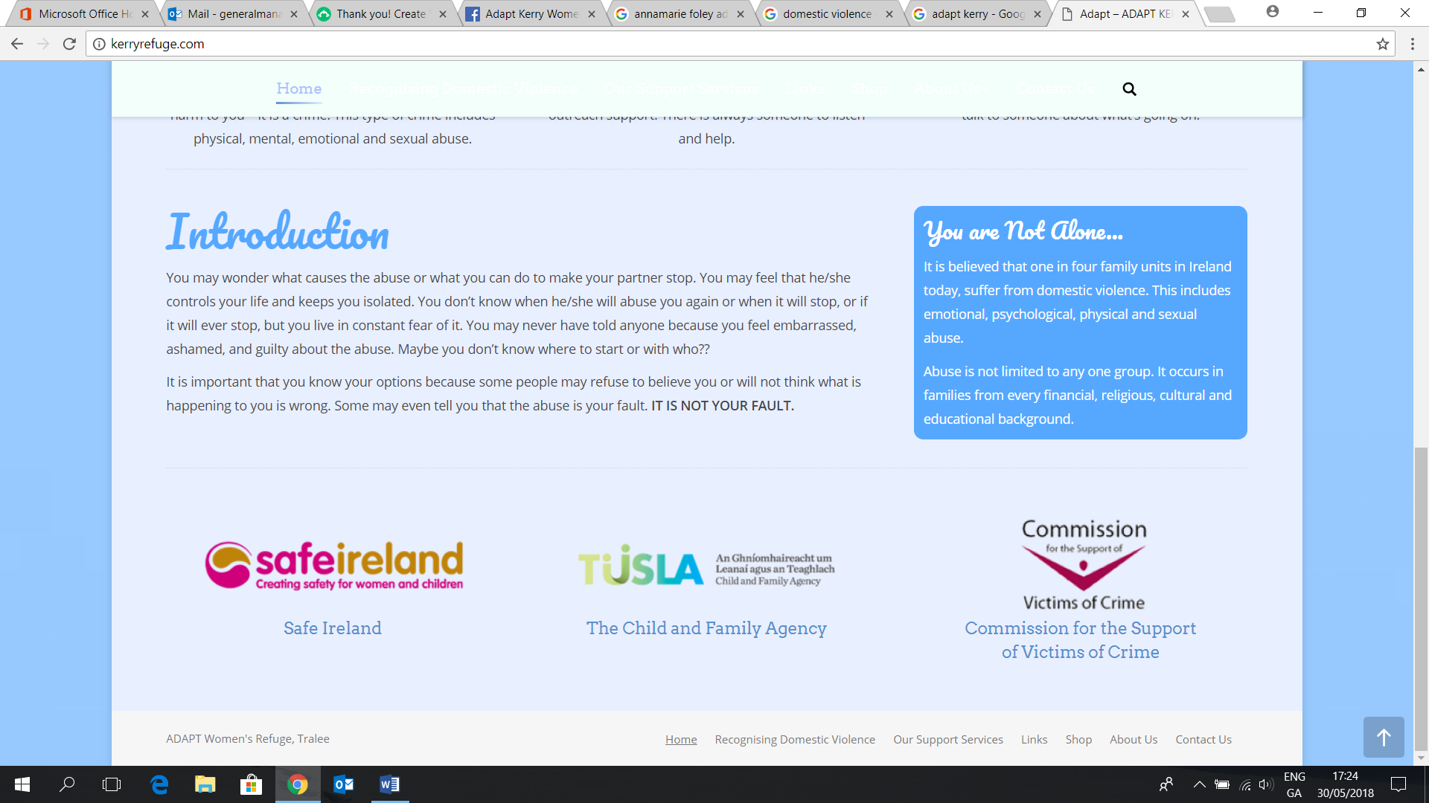

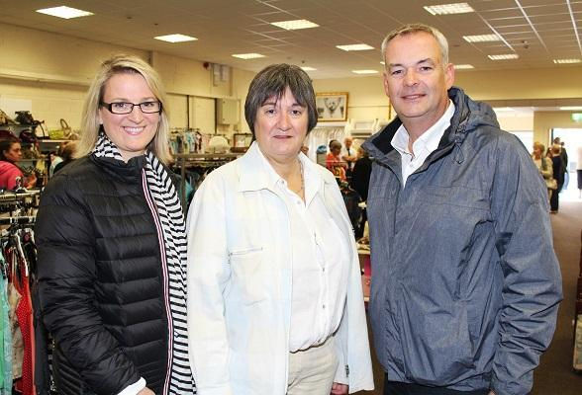

Chairperon’s Foreword

We are pleased to present our Annual Report for the year 2017. We hope that it will provide you with a comprehensive overview of our services and also a picture of service provision to our clients during the year.

Since we opened our doors in 1996, thousands of women and children have passed through our doors. These women and children, each a client in their own right, were forced to leave their family home due to domestic violence.

It is important also to acknowledge the many women who use our telephone support and outreach services as a means of accessing support and information. These services are vital in promoting the welfare and wellbeing of victims of domestic violence within their own communities and are an integral part of the supports which we offer to women each year.

Our direct work with victims of domestic violence informs our service provision. It also continues to challenge the way in which we work with women and children whose lives have been affected by domestic violence. The women with whom we are privileged to work hold the real expertise in the area of domestic violence and we continue to learn from them how best to meet their needs. Our work with women and children also allows us to hear their fears and concerns and through the medium of this report we hope to highlight these.

We also acknowledge that men in society are also victims of domestic violence. However, our service is currently resourced to support adult females and children only. We are nevertheless of the opinion that research is needed regarding both the prevalence of male victimization and the supports which male victims of domestic violence might require.

No support service continues to develop and thrive without a Board of Directors and Staff Team who share a vision that domestic violence is in its very essence a breach of human rights and should be challenged on that basis. In this regard the volunteerism of our Board of Directors and the energy and commitment of our staff is reflected in our response to the women and children for whom we work.

Any voluntary or community service is of course heavily dependent on the support of the State and its statutory agencies and we therefore work in partnership with The Child & Family Agency – TUSLA to deliver our refuge and outreach support services.

The support of the Commission for the Support of Victims of Crime and an Garda Siochana along with the Legal Aid Board also provides vital support to our service users in negotiating the legal system to seek protection and justice.

It is important to us also that the needs of our clients and the issue of domestic violence itself are reflected in our inter-agency work. In 2017 we worked with many agencies and their personnel in either direct advocacy work or in the promotion of issues which are pertinent to our work.

We appreciate the willingness of personnel in other agencies to listen to our concerns and to act where possible to promote the wellbeing of women and children alike. In particular we would like to acknowledge the support and commitment of the following people during 2017:

Ms. Joan Mullan TUSLA - The Child & Family Agency

Ms. Dairine Cross TUSLA – The Child & Family Agency

Ms. Ann O’Shea Office of The Commission for Victims of Crime

Chief Supt. Tom Myers An Garda Siochana

Ms. Caroline O’Brien Dept. Social Protection Community Welfare Office

(Homeless)

Mr. Ann Ronayne Kerry County Council Housing Officer

Ms. Carol Ann Coolican Tralee Law Centre Solicitor in Charge

The Management and Staff of the Homeless Information Centre.

Finally, but most importantly we acknowledge the strength and courage of the women and children with whom we work. Our ongoing aim is to continually develop and refine our service provision to ensure that victims of domestic violence receive the best and most effective response from us.

___________

Deirdre Murphy

Chairperson

History of Service

ADAPT Kerry CLG is a Company Limited by Guarantee, which operates Kerry Women's Refuge & Support Services. The company was incorporated, with charitable status in 1992 (CHY No. 10555/CRA No. 20027100).

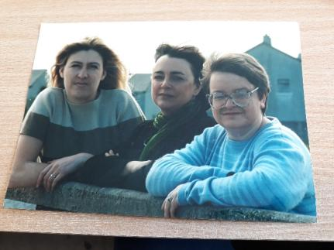

The Organisation has its origins in a group of concerned individuals, who, in the late 1980’s became aware of the issue of domestic violence, and the obstacles being faced by many women who were forced to leave the family home due to domestic violence.

Their initial thoughts were to establish a Court Accompaniment Service. However, it quickly became obvious that a key need was the establishment of a refuge for victims of domestic violence and their children, for the catchment area of County Kerry.

Many victims of domestic violence and their children, who were forced to abandon the family home due to violence inflicted by an abusive partner, had no option open to them, except to find temporary accommodation. In some cases, this meant bed & breakfast accommodation, or the homes of family members or friends. The nearest refuges at that time were in Counties Cork and Limerick.

A building committee was formed, which commenced work on obtaining grant approval for the purchase/construction of premises. The refuge opened its doors to the public in October 1996. The refuge, while located in Tralee, services the catchment area of Kerry.

**Organisational Structure:**

Board of Directors:

Ms. Deirdre Murphy Chairperson/Treasurer

Ms. Marion Hogan Company Secretary

Ms. Eileen Kelliher Director

Ms. Catherine Moriarty Director

**What is Domestic Violence?**

The Government Task Force Report on Violence against Women (1997) defines domestic violence as: “*The use of physical or emotional force or threat of force, including sexual violence, in close adult relationships. This includes violence perpetrated by a spouse, partner, son, daughter, or any other person who has a close blood relationship with the victim.*

*The term Domestic Violence goes beyond actual physical violence. It can involve emotional abuse, the destruction of property, isolation from friends, family and other potential sources of support: Threats to others including children: stalking: and control over access to money personal items, food, transportation, and the telephone*.” (Report of the National Task Force on Violence Against Women: 1997:27).

Our Aim for our Service is to offer:

The Refuge Service

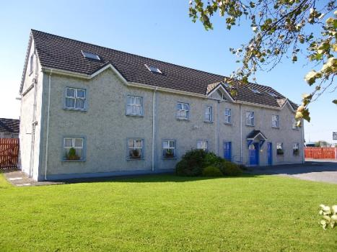

The refuge service provides women with some breathing space, where with the support of staff, they can identify their own individual support needs. The refuge consists of a total of six self-contained apartments and can therefore accommodate a total of six families at any one time.

The primary services, which are offered to families’ resident in the refuge, are:

While each family shares service facilities with other families, they also have the added comfort and privacy of their own completely self-contained apartment consisting of kitchen/living/dining area, bedroom, and bathroom. This allows each family to maintain as much as possible, their own familiar daily family routines that will provide added reassurance and stability for their children.

Once admitted, we encourage clients to settle themselves a little and then our team of support workers begins working with each client on the needs, which they themselves have identified.

Client Needs and Supports

These needs can be wide-ranging and a client may choose to use their time with us in a variety of different ways:

* As a period of badly needed respite from her abuser
* To access legal advice and representation for Court Proceedings
* To access support from the following:
* Social Worker
* Public Health Nurse
* General Medical Services
* To make applications to statutory agencies e.g.
* Their Local Housing Authority
* The Community Welfare Office
* The Department of Social Protection
* The Legal Aid Board
* To access supports from other external agencies e.g.
* Kerry Money Advice & Budgeting Service
* Counselling Services
* Crisis Pregnancy Services



*In 2017 64 Individual Women*

*were admitted to Refuge*

The Outreach Support Service



Our outreach support service was developed in response to a need identified by our clients. Many women told us that they found the transition of leaving the high-support environment of the refuge to independent living very difficult.

We were also conscious that there were many women who for various reasons were not in a position to come to the refuge for support, but who still required ongoing emotional and practical support. With this in mind, we sought core funding to develop an outreach service that is available county wide.

**The Aims and Objectives of our Outreach Service:**

We aim to provide a non-judgmental, listening service for women with experience of domestic violence. We aim to support, inform, and facilitate our clients by the following means:

* Providing an accessible service, which is either outreach location based in a mutually agreed safe place, or in exceptional circumstances in the woman’s home.
* Being flexible and where possible tailoring the service to meet the woman’s needs.
* Providing accompaniment to Court and to statutory and voluntary agencies as requested.
* Advocating on behalf of and with the client to relevant agencies and services.
* Networking with other agencies and services on behalf of our clients.
* Providing information to women on issues regarding housing, finance, legal, health, counselling, employment, education, and training, childcare facilities and schools and any other issues identified as relevant.
* Maintaining visibility in the community through awareness raising presentations and through representation at relevant network and committee meetings.

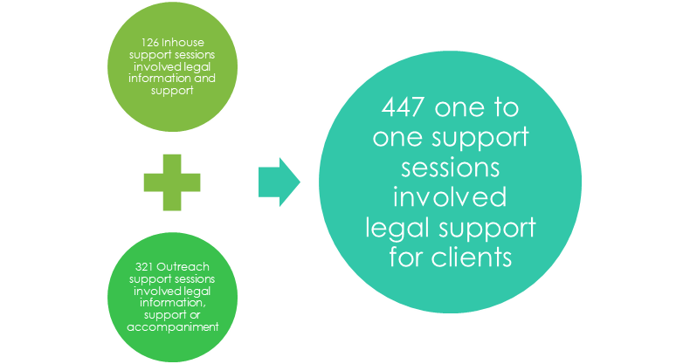

In 2017:

*Of the 590 telephone and front door contacts in 2017; 123 were first time women seeking support*

The Outreach Support Service operates from the refuge on Tuesdays/Wednesday/Thursdays/Fridays with both workers travelling on a countywide basis to meet women in their own localities, offering information and support. This service is a free of charge and can be accessed by telephoning our main number to schedule an appointment. For many women, coming to stay in the refuge is not a possibility, for many reasons. It is therefore vital that these women can access both emotional and practical support in their own locality, when needed.

The number of women who are using the outreach support service in particular, has in general increased on a yearly basis. In 2017 we saw the appointment of a new Outreach Support Worker who works in a part time capacity.

Children in Refuge

[](https://www.bing.com/images/search?q=children+and+domestic+violence&view=detailv2&&id=A52AA452B3A668629B794EB487AF676CD1A13C3A&selectedIndex=8&ccid=p6t4dx/7&simid=608020941693454028&thid=OIP.Ma7ab78771ffb039a04534fa98ea87ec9o0)Domestic Violence affects children in different ways. The effects range from physical, emotional and psychological and have short, medium and long-term consequences. We believe that quite often children are the “silent” victims of domestic violence. Each child who is resident with us is viewed, as a client in his/her own right with his/her own particular support needs.

*There were 82 individual young people admitted to ADAPT Kerry in 2017*



It is our policy to safeguard the welfare of all children within our care from all forms of abuse, by ensuring that correct procedures are followed with regard to the prevention and reporting of child abuse. Our approach is child centred, and we believe that the child is never to blame for any abuse that s/he may suffer. Our Child Protection & Welfare Policy has been developed in accordance with the *Children First* guidelines and in conjunction with The Child & Family Agency - TUSLA.

Under this policy, we have established agreed notification and referral procedures with the Social Work Department of The Child & Family Agency - TUSLA. Through these mechanisms, we aim to ensure that child protection and welfare concerns are referred in the most effective and supportive manner possible.

Funding

Like any other service in the voluntary and community sector we rely on funding from a number of different sources to fund and support the services, which we offer. Our principal core funders in 2017 were as follows:

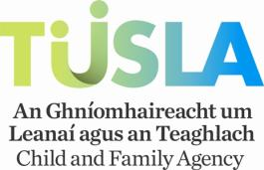

* The Child & Family Agency - TUSLA
* The Commission for The Support of Victims of Crime*

TUSLA:

Our service continues to work in partnership with TUSLA to provide the best possible outcomes for women and children whose lives are affected by Domestic Violence. We are extremely grateful to TUSLA for their ongoing support.

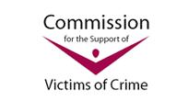The Commission for the Support of Victims of Crime:

*The Commission is based in The Department of Justice and provides this funding, for the provision of Court Accompaniment/Victim Support Services. This funding is of enormous benefit to us as an organisation as it allows us to build our capacity in this area and offer the following supports to clients:

* The provision of information on Legal Services available
* Referral to Legal Services and in particular the Legal Aid Board
* Assistance with the completion of application forms for Legal Aid
* Accompaniment to appointments at the Legal Aid Board where appropriate
* Accompaniment to the Court Clerk’s Office so that required documentation can be completed vis-à-vis an application for a Court Order
* Accompaniment to the Court on the day of hearing of the application
* Follow-up support regarding the outcome of the Hearing.

This funding has ensured that all women, who approach us in this regard, are offered support in this area. Our experience to-date is that women are more informed on what their options are and when availing of the supports offered, are more open to seeking the Protection of the Courts. Women, in turn, who have engaged with the system on previous occasions, have also told us that their experience this time round is better with a continuum of support.

We are also extremely grateful to the Commission for their support and assistance with our work.

A Look Back at 2017’s Funding

The Board of Directors would in particular wish to acknowledge the ongoing support of TUSLA – The Child & Family Support Agency and The Support of Victims of Crime.

Our key funding/income in 2017 was as follows:

TUSLA – Child & Family Agency €469,311.00

Fundraising/Donations: € 11,334

Commission for the Support of Victims of Crime: €18,400

Charity Shop Income: €179,198

_______________

Our total funding in 2017 €687,090



As a member organisation of Safe Ireland ADAPT Kerry believe in their ambition that Ireland can be the safest country in the world for women and children



Fundraising

Our Fundraising and Volunteer Co-Ordinator has allowed us to build capacity and sustainability across the organisation. The focus of this position has been to continue to grow our Charity Shop for the service, to enable the Company to generate an independent income stream of its own, with which it can not only build its reserves, but also target additional areas of service provision and support for clients.

The Charity Shop opened its doors in July 2016 and has been very successful to date and is well supported by the local community.

We are also heavily dependent on the generosity of the local community who kindly make donations to the service each year. These donations allow us to provide the additional supports and comfort which women and children require during their stay with us. We are once again, indebted to the wider community of Kerry for its ongoing support of our work.

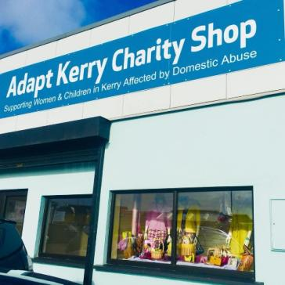SERVICE DEVELOPMENT:

Charity Shop:

The Charity Shop opened its doors on June 23rd 2016 and to date it has been well supported by the local community.

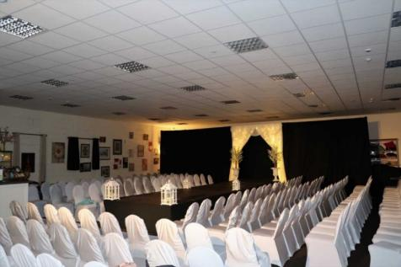

On 20th October 2017, the Charity Shop held a Fashion Show, which was a spectacular success raising over €3,000 on the night; with the food, drinks, music, models, all given at no cost to the Service.

The Shop also won the Rags to the Runway competition, a Charity shop event on 12th March. This was an opportunity to showcase the clothes and quality of the merchandise being sold in the Charity Shop.



Our Christmas sales were also remarkable, with a Toy Sale event raising €3,000 and an ‘All things Christmas’ event raising €5,000.

### Additionally we held two flag days in 2017; May and November raising €1927.35 and €2753.80 respectfully.

**Community Support Initiatives**

**Food Cloud:**

Food Cloud is an innovative organisation that connects businesses that have too much food with charities that have too little. In 2014, Food Cloud extended the service to Kerry in partnership with TESCO. In 2015 ALDI also signed up as a partner and we have continued to be a recipient through 2017.

This initiative has been incredibly beneficial for our clients, as on one day a week we collect food from TESCO at Manor, Tralee and ALDI on John Joe Sheehy Road and distribute it to both refuge and outreach clients. This provides families with a great variety of free fresh food. We are very grateful to the teams at Food Cloud, TESCO and ALDI for their support.

**Food Share:**

Foodshare Kerry, an initiative of North & East Kerry Development and Saint Vincent de Paul, is an not-for-profit organisation set up to help local charity groups combat food poverty.

We have also been very grateful for the support of the Kerry Food Share in 2017. We have received deliveries of food on a fortnightly basis which have allowed us to be able to put together food hampers for families as they come into Refuge. The food has also been given to clients of the Outreach Service.

**Round Robin Hampers**

We were very appreciative for the continued support from the Round Robin Group who organize collections of food hampers for families at Christmas time.

**Staff Support/Training:**

**Child Protection:**

* All support staff completed the E-Learning module in Children First.
* The Team Leader (Maternity leave) completed the Always Children First in April 2017.
* The Designated Liaison Persons also attended Briefings in relation to the Children First Act 2015 regulation in preparation for the changes to the Child Protection Policy.

**Foundation Programme in Sexual Health:**

* Three of the Support Staff participated in the Foundation Programme in Sexual Health Promotion Training.

**‘In Safe Hands’ Conference, Cork:**

* Two of the Support team attended the ‘In Safe Hands’ Conference in Cork, February 2017.

**Safe Ireland Training:**

Staff also attended the following Safe Ireland training workshops

* ‘Exploring solutions to enable housing stability for women and children experiencing domestic violence’.
* New & emerging legislation relating to domestic violence provision in Ireland
* Briefing in relation to Database and data protection

**Tusla Training**

* Dialogue Day workshop on User participation in Domestic, Sexual and Gender based Violence Services
* 1 Staff member attended the Commissioning Service Agreement in Cork, November 2017
* Commissioning for Domestic, Sexual and Gender Based Violence Services Briefing, December 2017
* 1 staff member attended a briefing on the National Aftercare Policy, Guidance & Legislation

**Housing Agency**

* 1 staff member attended a briefing on submitting an Annual Regulatory Return, 2017

**GDPR**

* 2 staff members attended a day long programme on GDPR organized by IBEC

**Other training:**

Staff also attended the following Safe Ireland training workshops

* 1 staff member attended an Introduction to Domestic Violence level 1 & 2
* 1 staff member attended training on Understanding Domestic Abuse
* 4 staff members attended a briefing on Female Genital Mutilation
* 3 staff members attended an information session on Transgender issues
* All staff attended a workshop on Understanding Trauma and Supporting Refugees
* 1 staff member and 1 Board Member attended a seminar organized by the West Cork Women’s Project with Stephanie Holt of Trinity University, Dublin

Interagency Work

As part of our ongoing commitment to clients we have been involved with a number of different relevant agencies throughout the year. We would have continued to maintain excellent working relations with Kerry Rape and Sexual Abuse Centre, Family Resource Centre’s, Jigsaw, Kerry Traveler Community Development Project, the International Resource Centre, and the Tralee Women’s Resource Centre.

*IN 2017, 12.5% of telephone calls were from Professionals or Agencies, working with families looking for support or information*

We have continued to sit on the Tralee Child and Family Network Meetings and have also had the opportunity to visit other Network Meetings in Kerry highlighting the availability of our services in different parts of the County.

We have continued to represent the women and children who use our service on the Kerry County Homeless Forum which is run by the Housing Department of Kerry County Council.

Our commitment to the children that use our service is reflected in the work that we do liaising with schools, preschools, family support agencies as well as Tusla’s Social Work Department.

***154*** *Clients accessed support around legal issues through the Outreach Support Service, Inhouse Support and Telephone Support*

Awareness Raising

As part of our ongoing commitment to raising the awareness of Domestic Abuse in our Community we have also given presentations to different organisations in 2017 such as; Nurses at the Accident and Emergency Department in University Hospital Kerry, to HSE staff, Social Welfare staff as well as at the Kerry Women Rise event marking the 16 Days of Action in November.

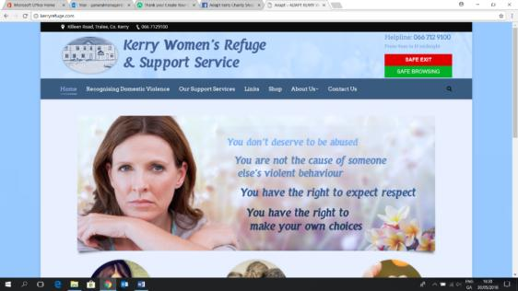

Our Website had been updated in 2016 and continues to be an important medium for our service to offer women insights into domestic violence and the services that we provide.

The ADAPT Facebook continued to be maintained by our Team Leader whilst our Charity Shop Page was maintained by our Fundraising & Volunteer Coordinator.

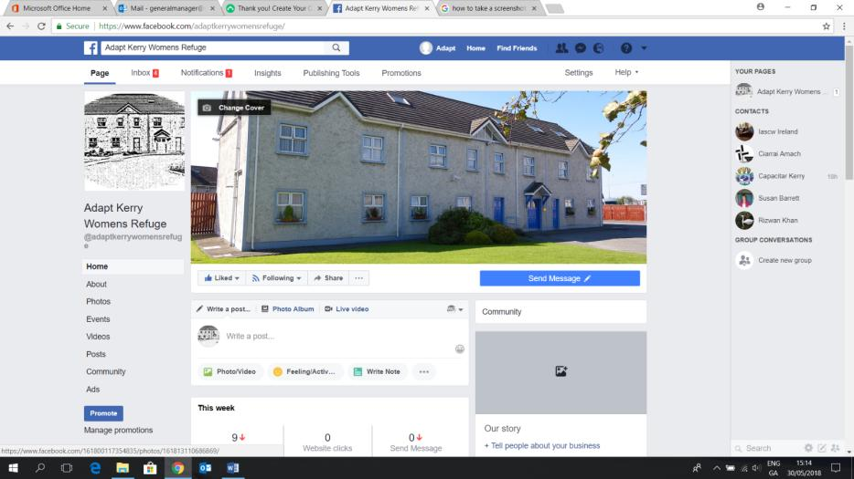

Staffing:

IN June 2017, we saw the introduction of new working hours in the Refuge and a change to the Rota for staff members signaling the end of the Workplace Relations issue.

Refuge Service was made available from:

Monday to Friday 8.30am until 12 midnight

Saturday and Sunday 2pm to 12 midnight. – These hours have since changed to Saturday and Sunday from 1pm to 11pm.

One of the Night Support Team have now been welcomed as part of the Day Support Team. This new role allows as a dedicated Day Support Worker will work directly with the women on a one-to-one basis as well as acting as an advocate with relevant agencies. This new position will allow the Team Leader’s position to be expanded and developed in the coming years.

We would like to wish our General Manager, AnnaMarie Foley our best wishes as she has been on Sick Leave; we hope to see her return to her position in 2018. The General Manager position had been filled by the Team Leader (both temporary (maternity leave) and permanent staff during 2017) and also with the gracious support of Ms. Denise Dunn, Assistant Director of Adapt Limerick who kindly provided professional assistance during the summer of 2017.

We would also like to acknowledge the unwavering support of the Board of Directors through 2017; the Board went above and beyond in their role to ensure that the service continued to deliver such a vital support in the Community.

Community Employment Scheme:

The Community Employment Scheme has continued to support ADAPT Kerry under the guidance of Anne Connolly, Friends of Able CE Scheme.

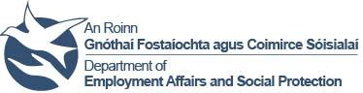There are four Housekeeping positions, two Maintenance positions as well as two Receptionist positions on the CE Scheme.

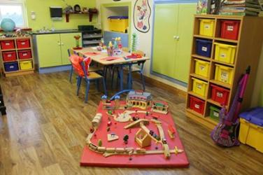

*In 2017 we had 82 individual children admitted to Refuge;*

*Some families presented for re-admission during the year, which meant that 150 was the total of children admitted & re-admitted with their mother during the year.*

Area’s of Concern:

**The use of Collaborative Law in the context of Domestic Violence:**

All Domestic Violence services continue to be concerned at the increasing incidence of the use of collaborative law practices in the case of applications to the Courts under the Domestic Violence Acts. The practice of collaborative law in the context of domestic violence is resulting in many women leaving Court with an Undertaking between both parties, rather than a full Order of the Court. Our experience is that quite often these Undertakings break down within a matter of a week, placing women and children in continuing vulnerable situations.

*One fifth of women presenting to the Refuge in 2017 were not accommodated as they were experiencing homelessness with no domestic abuse reported*

**Domestic Violence and Homelessness:**

Whilst Domestic Violence is recognized as grounds for Homelessness under the National Homeless Strategy, many women suffering domestic violence are now finding their housing options limited, as Local Authorities move to address increasing demands for social housing, by introducing stringent criteria for housing applicants.

Whilst as a service we continue to have very supportive relationships with Kerry Local Authorities, which facilitate assistance such as the fast-tracking of Housing Need Assessments for women in refuge, we are nevertheless finding that for some women, moving on from refuge is problematic due to the lack of suitable and affordable accommodation in the County.

Service Usage At a Glance  **2017**

Individual Women Admitted to Refuge 64

Individual Child Admissions to Refuge 82

Total Women Admissions to Refuge 87

Total Child Admissions to Refuge 150

Individual Women using Outreach Support Service 111

Individual Women accessing support on legal issues 154

Helpline Calls 524

*In 2017 we had 206 requests for space*

*50% of these we were unable to accommodate*

***Almost 60% of these were due to lack of space in Refuge***

**ADAPT Kerry CLG**

**Public Statement of Compliance with the Statement for Guiding Principles for Fundraising**

ADAPT Kerry is committed to complying with the *Statement for Guiding Principles for Fundraising* and has formally discussed and adopted the Statement at a meeting of our Board of Directors

ADAPT Kerry confirms its commitment to the principles set out in the *Statement of Guiding Principles for Fundraising* by a statement to that effect in its Annual Report.

ADAPT Kerry has a Donor Charter which is consistent with the *Statement of Guiding Principles for Fundraising*

ADAPT Kerry regularly monitors compliance with the *Statement of Guiding Principles for Fundraising* and compliance reports are received regularly by the Board of Directors

ADAPT Kerry considers the *Statement of Guiding Principles for Fundraising* when planning all fundraising activity

ADAPT Kerry has a policy on working with third party fundraisers

ADAPT Kerry provides honest, open and transparent disclosure when fundraising from the Public

ADAPT Kerry has appointed a senior member of staff to be responsible for compliance with the *Statement of Guiding Principles for Fundraising*

Cont’d:

ADAPT Kerry ensures that fundraising staff are provided with information and training on the Statement of Guiding Principles for Fundraising and its implementation

ADAPT Kerry has a feedback and complaints procedure consistent with the *Statement of Guiding Principles for Fundraising*. Feedback is recorded for review by relevant staff including the General Manager and the Board of Directors. Feedback is responded to promptly and appropriately.

ADAPT Kerry prepares financial reports consistent with the requirements of the Charities Act 2009 which include a statement concerning the extent to which control of the organisation is independent of its funding sources.

ADAPT Kerry ensures that all donations are tracked and recorded and complies with Data Protection requirements.

ADAPT Kerry is accessible to the public through a number of readily available contact options. If you would like to contact us you can contact Ms. Emma O Mahony, (Acting) General Manager by:

Writing to: ADAPT Kerry

Killeen Road,

Tralee

County Kerry

Telephoning: (066) 7129100

Faxing: (066) 7127836

Emailing: generalmanager@kerryrefuge.com

**ADAPT KERRY**

**DONOR CHARTER**

As a charity seeking donations from the public we, ADAPT Kerry, aim to comply with

the *Statement of Guiding Principles for Fundraising*

Our pledge is to treat all our donors with respect, honesty and openness.

We commit to being accountable and transparent so that donors and prospective donors

can have full confidence in ADAPT Kerry.

We promise we will effectively apply your gifts to us for their intended purposes

We commit that you, our donors and prospective donors will:

* Be informed of our mission, and of the way the organisation intends to use donated resources.
* Be informed of the identity of those serving on our Board of Directors, and that the Board of Directors will exercise prudent judgement in its stewardship responsibilities.
* Have access to our most recent financial statements.
* Be assured your gifts will be used for the purposes for which they were given.
* Receive appropriate acknowledgement and recognition from us.
* Be assured that information about your donation is handled with respect and with confidentiality to the extent provided by law
* Expect that all relationships with individuals representing ADAPT Kerry will be dealt with professionally
* Be informed whether those seeking donations are volunteers, employees of the organisation or hired third party agents
* Have easily available the agreed procedures for making and responding to complaints
* Have the opportunity for any names to be deleted from mailing lists and to be informed if the organisation intends to share the mailing lists with third parties
* Receive prompt, truthful and forthright answers to questions you might have of us

**What to do if you have feedback**

If you do have a comment about any aspect of our work, you can contact ADAPT Kerry Limited in writing or by telephone. In the first instance, your comment will be dealt with by our General Manager.

Please give us as much information as possible and let us know how you would like us to respond, providing relevant contact details.

Please Write to:

Ms. Emma O Mahony

(Acting) General Manager

ADAPT Kerry Limited

Killeen Road

Tralee

County Kerry

Ireland

Tel: +353 66 7129100

Facsimile: +353 66 7127836

Email: [generalmanager@kerryrefuge.com](mailto:generalmanager@kerryrefuge.com)

Monday – Friday: 9.00 a.m. – 5.00 p.m.

